Daniel Williamson

Project #6

4/19/17

EE 222

Project Overview

Purpose:

The purpose of this project was to implement both insertion and selection sort. We randomly generate an unordered list of integers. And then using either insertion or selection, we sort the unordered list.

Approach:

To begin, I needed to understand what the files provided were doing. Thankfully, once again, unlike the previous projects, it was rather clear and easy on what was needed to be done. Having just the one make file, made it much more clear. After getting the code to run I started filling in the functions. I began with a random helper method to randomly choose integers and populate an unordered list. Once I believed that worked. I needed to see if it was running correctly, so I immediately went to the method for printing out a list. After completing that, I could see, both my randomizer and print list functions were working properly. Now it was just onto using the correct logic on the selection and insertion sort methods.

Results:

This is selections sort in progress:

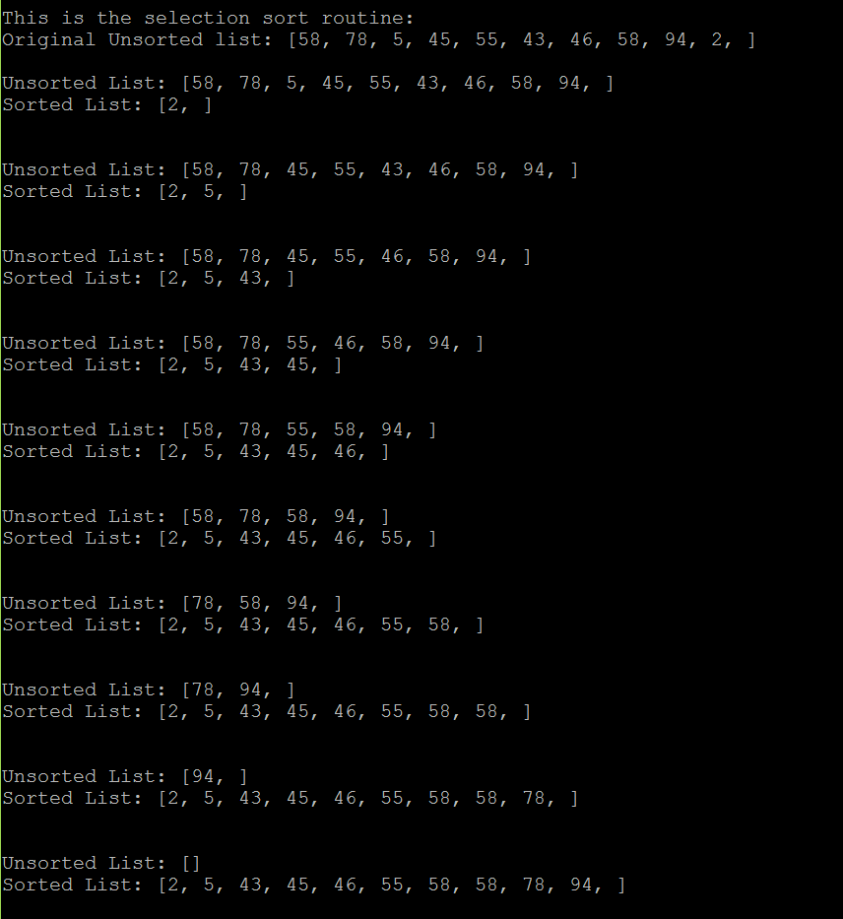

This is insertion sort in progress:

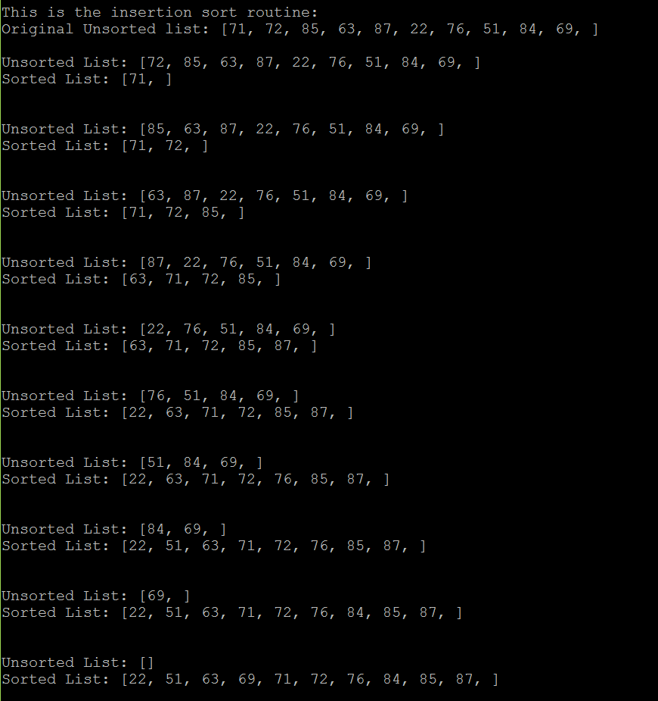

Conclusion:

In conclusion, this was a moderate lab. Understanding how insertion and selection sort work made this lab easier. Writing and drawing it out made it much easier. The most difficult part I ran into was getting the randomized integer array to work properly. It was giving me lots of errors. To overcome this, I spoke to a few friends and they pointed out to me the mistake I was making.